

Title of the Article (3 lines at most)

Author #1¹, Author #2², Author #3^{3*}, etc.

¹Affiliation line #1, two lines at most. University, Department, City, Zip, Country
²Affiliation line #2, two lines at most. University, Department, City, Zip, Country
³Affiliation line #3, two lines at most. University, Department, City, Zip, Country

Abstract: Maximum 250 words.

Keywords: Minimum 3, maximum 6.

*Corresponding author (E-mail is compulsory, providing telephone and fax numbers are optional)

1. INTRODUCTION (All capitals, one space before and after the heading)

(10 pt, Verdana, 1.5 paragraph spacing)
Lorem ipsum dolor sit amet, consectetur adipiscing elit. Maecenas pellentesque imperdiet lectus, pellentesque semper eros pretium in. Morbi finibus urna nec nisi facilisis tempor. Vestibulum a quam ut ipsum rutrum laoreet eget id purus. Donec in aliquet enim, id finibus diam. Aliquam interdum ac nibh non consectetur. Phasellus imperdiet sapien tortor, vel fringilla nunc placerat quis. Nulla scelerisque velit quis dignissim volutpat. Integer vulputate eu libero et pellentesque. Praesent quis scelerisque tellus. Ut eu scelerisque dui (1-3).

Aenean fermentum sem libero, nec tristique sapien pulvinar in. Phasellus non auctor enim. Curabitur sed ex lacinia, accumsan est nec, consequat eros. Cras finibus euismod lorem viverra rutrum. Nunc faucibus nec dui ut egestas. Integer ullamcorper, quam id aliquet condimentum, erat neque elementum metus, vel ornare risus mauris id erat (4). Pellentesque auctor eros massa, sed malesuada purus lobortis sit amet. Fusce mi elit, imperdiet vitae urna et, aliquam pretium risus. Vestibulum sagittis, dui vitae interdum scelerisque, nibh lectus accumsan magna, nec euismod eros nulla a lorem. Aliquam pretium dui augue, sed tempus augue molestie non. Suspendisse blandit cursus vestibulum. Integer accumsan dui in risus aliquam, at fermentum urna hendrerit. Suspendisse pretium eu enim et pellentesque. Mauris tempor metus vitae iaculis feugiat. Cras in vulputate nunc. Nullam eleifend et arcu id finibus (1, 5-8).

Vivamus at magna hendrerit, euismod ante eget, aliquam neque. In efficitur sit amet dolor accumsan consequat. Fusce enim justo, bibendum eu dolor et, ornare vulputate lacus. In hac habitasse platea dictumst. Phasellus quis ante et ligula ultricies mollis id ut sem. In hac habitasse platea dictumst. In ante lectus, facilisis eu enim dictum, mattis scelerisque purus. Pellentesque ultrices consequat nisl, eget rhoncus nibh molestie nec. Donec ante velit, iaculis id lacinia nec, finibus ut lacus. Donec congue turpis vitae viverra aliquet. In sed gravida odio. Donec efficitur scelerisque molestie. Vivamus pellentesque dapibus sapien, in elementum quam elementum eu (9-12).

2. EXPERIMENTAL SECTION (All capitals, one space before and after the heading)

2.1. Second Degree Heading (One Space Before The Heading, No Space After The Heading)
Lorem ipsum dolor sit amet, consectetur adipiscing elit. Maecenas pellentesque imperdiet lectus, pellentesque semper eros pretium in. Morbi finibus urna nec nisi facilisis tempor. Vestibulum a quam ut ipsum rutrum laoreet eget id purus. Donec in aliquet enim, id finibus diam. Aliquam interdum ac nibh non consectetur. Phasellus imperdiet sapien tortor, vel fringilla nunc placerat quis. Nulla scelerisque velit quis dignissim volutpat. Integer vulputate eu libero et pellentesque. Praesent quis scelerisque tellus. Ut eu scelerisque dui.

2.2. Second Degree Heading (One Space Before The Heading, No Space After The Heading)
Lorem ipsum dolor sit amet, consectetur adipiscing elit. Maecenas pellentesque imperdiet lectus, pellentesque semper eros pretium in. Morbi finibus urna nec nisi facilisis tempor. Vestibulum a quam ut ipsum rutrum laoreet eget id purus. Donec in aliquet enim, id finibus diam. Aliquam interdum ac nibh non consectetur. Phasellus imperdiet sapien tortor, vel fringilla nunc placerat quis. Nulla scelerisque velit quis dignissim volutpat. Integer vulputate eu libero et pellentesque. Praesent quis scelerisque tellus. Ut eu scelerisque dui.

Aenean fermentum sem libero, nec tristique sapien pulvinar in. Phasellus non auctor enim. Curabitur sed ex lacinia, accumsan est nec, consequat eros. Cras finibus euismod lorem viverra rutrum. Nunc faucibus nec dui ut egestas. Integer ullamcorper, quam id aliquet condimentum, erat neque elementum metus, vel ornare risus mauris id erat. Pellentesque auctor eros massa, sed malesuada purus lobortis sit amet. Fusce mi elit, imperdiet vitae urna et, aliquam pretium risus. Vestibulum sagittis, dui vitae interdum scelerisque, nibh lectus accumsan magna, nec euismod eros nulla a lorem. Aliquam pretium dui augue, sed tempus augue molestie non. Suspendisse blandit cursus vestibulum. Integer accumsan dui in risus aliquam, at fermentum urna hendrerit. Suspendisse pretium eu enim et pellentesque. Mauris tempor metus vitae iaculis feugiat. Cras in vulputate nunc. Nullam eleifend et arcu id finibus.

2.3. Second Degree Heading (One Space Before The Heading, No Space After The Heading)
Lorem ipsum dolor sit amet, consectetur adipiscing elit. Maecenas pellentesque imperdiet lectus, pellentesque semper eros pretium in. Morbi finibus urna nec nisi facilisis tempor. Vestibulum a quam ut ipsum rutrum laoreet eget id purus. Donec in aliquet enim, id finibus diam. Aliquam interdum ac nibh non consectetur. Phasellus imperdiet sapien tortor, vel fringilla nunc placerat quis. Nulla scelerisque velit quis dignissim volutpat. Integer vulputate eu libero et pellentesque. Praesent quis scelerisque tellus. Ut eu scelerisque dui.

2.3.1. Third degree heading (one space before heading, heading is italic)
Lorem ipsum dolor sit amet, consectetur adipiscing elit. Maecenas pellentesque imperdiet lectus, pellentesque semper eros pretium in. Morbi finibus urna nec nisi facilisis tempor. Vestibulum a quam ut ipsum rutrum laoreet eget id purus. Donec in aliquet enim, id finibus diam. Aliquam interdum ac nibh non consectetur. Phasellus imperdiet sapien tortor, vel fringilla nunc placerat quis. Nulla scelerisque velit quis dignissim volutpat. Integer vulputate eu libero et pellentesque. Praesent quis scelerisque tellus. Ut eu scelerisque dui.

2.3.2. Third degree heading (one space before heading, heading is italic)
Lorem ipsum dolor sit amet, consectetur adipiscing elit. Maecenas pellentesque imperdiet lectus, pellentesque semper eros pretium in. Morbi finibus urna nec nisi facilisis tempor. Vestibulum a quam ut ipsum rutrum laoreet eget id purus. Donec in aliquet enim, id finibus diam. Aliquam interdum ac nibh non consectetur. Phasellus imperdiet sapien tortor, vel fringilla nunc placerat quis. Nulla scelerisque velit quis dignissim volutpat. Integer vulputate eu libero et pellentesque. Praesent quis scelerisque tellus. Ut eu scelerisque dui.

Aenean fermentum sem libero, nec tristique sapien pulvinar in. Phasellus non auctor enim. Curabitur sed ex lacinia, accumsan est nec, consequat eros. Cras finibus euismod lorem viverra rutrum. Nunc faucibus nec dui ut egestas. Integer ullamcorper, quam id aliquet condimentum, erat neque elementum metus, vel ornare risus mauris id erat. Pellentesque auctor eros massa, sed malesuada purus lobortis sit amet. Fusce mi elit, imperdiet vitae urna et, aliquam pretium risus. Vestibulum sagittis, dui vitae interdum scelerisque, nibh lectus accumsan magna, nec euismod eros nulla a lorem. Aliquam pretium dui augue, sed tempus augue molestie non. Suspendisse blandit cursus vestibulum. Integer accumsan dui in risus aliquam, at fermentum urna hendrerit. Suspendisse pretium eu enim et pellentesque. Mauris tempor metus vitae iaculis feugiat. Cras in vulputate nunc. Nullam eleifend et arcu id finibus.

3. RESULTS AND DISCUSSION

Lorem ipsum dolor sit amet, consectetur adipiscing elit. Maecenas pellentesque imperdiet lectus, pellentesque semper eros pretium in. Morbi finibus urna nec nisi facilisis tempor. Vestibulum a quam ut ipsum rutrum laoreet eget id purus. Donec in aliquet enim, id finibus diam. Aliquam interdum ac nibh non consectetur. Phasellus imperdiet sapien tortor, vel fringilla nunc placerat quis. Nulla scelerisque velit quis dignissim volutpat. Integer vulputate eu libero et pellentesque. Praesent quis scelerisque tellus. Ut eu scelerisque dui (13-18).

Aenean fermentum sem libero, nec tristique sapien pulvinar in. Phasellus non auctor enim. Curabitur sed ex lacinia, accumsan est nec, consequat eros. Cras finibus euismod lorem viverra rutrum. Nunc faucibus nec dui ut egestas. Integer ullamcorper, quam id aliquet condimentum, erat neque elementum metus, vel ornare risus mauris id erat. Pellentesque auctor eros massa, sed malesuada purus lobortis sit amet. Fusce mi elit, imperdiet vitae urna et, aliquam pretium risus. Vestibulum sagittis, dui vitae interdum scelerisque, nibh lectus accumsan magna, nec euismod eros nulla a lorem. Aliquam pretium dui augue, sed tempus augue molestie non. Suspendisse blandit cursus vestibulum. Integer accumsan dui in risus aliquam, at fermentum urna hendrerit. Suspendisse pretium eu enim et pellentesque. Mauris tempor metus vitae iaculis feugiat. Cras in vulputate nunc. Nullam eleifend et arcu id finibus (19).

Vivamus at magna hendrerit, euismod ante eget, aliquam neque. In efficitur sit amet dolor accumsan consequat. Fusce enim justo, bibendum eu dolor et, ornare vulputate lacus. In hac habitasse platea dictumst. Phasellus quis ante et ligula ultricies mollis id ut sem. In hac habitasse platea dictumst. In ante lectus, facilisis eu enim dictum, mattis scelerisque purus. Pellentesque ultrices consequat nisl, eget rhoncus nibh molestie nec. Donec ante velit, iaculis id lacinia nec, finibus ut lacus. Donec congue turpis vitae viverra aliquet. In sed gravida odio. Donec efficitur scelerisque molestie. Vivamus pellentesque dapibus sapien, in elementum quam elementum eu (20-22).

Table 1: Distribution of the elements in the milk sample.
Element | Concentration (mg/L)
Calcium | 1500
Magnesium | 700
Potassium | 500
Sodium | 350
Lithium | 15

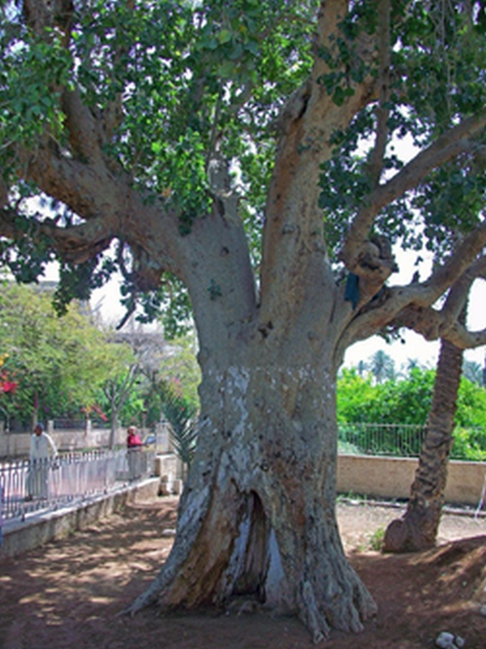
Figure 1: A tree (Minimum image resolution is 300 DPI; using irfanview at https://www.irfanview.com is recommended).

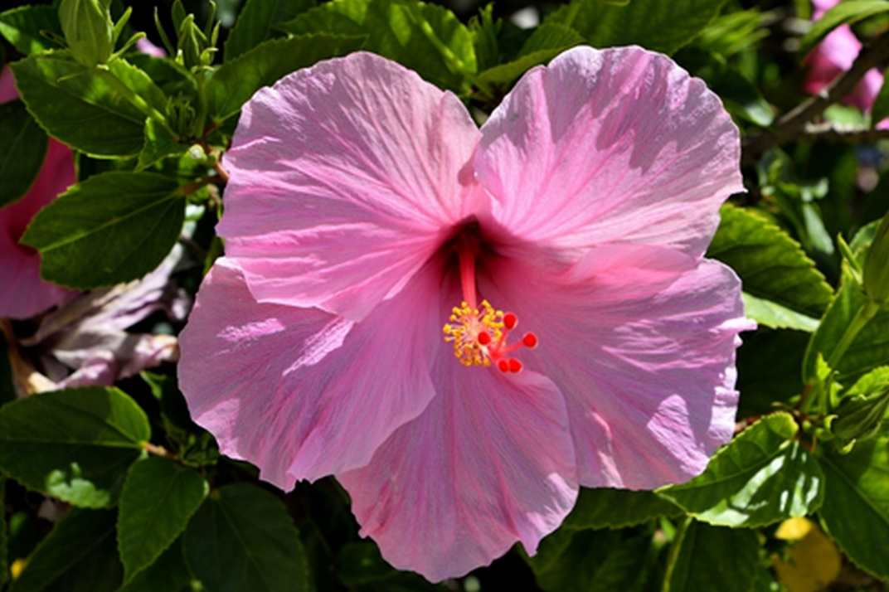
Figure 2: A flower (Minimum image resolution is 300 DPI; using irfanview at https://www.irfanview.com is recommended).

Giving Nuclear Magnetic Resonance Data: ¹H NMR (400 MHz, CDCl₃, δ, ppm): 7.53-7.47 (2H, m, Ar-H), 7.42-7.35 (3H, m, Ar-H), 5.54 (1H, s, PhCH-), 4.80 (1H, d, J = 4.0 Hz, H-1), 4.30 (1H, dd, J = 9.7 and 4.4 Hz, H-6a), 3.94 (1H, dd, J = 9.3 and 9.2 Hz, H-3), 3.82 (1H, ddd, J = 10.3, 9.2 and 4.4 Hz, H-5), 3.75 (1H, dd, J = 10.3 and 9.7 Hz, H-6b), 3.64 (1H, dd, J = 9.2 and 4.0 Hz, H-2), 3.50 (1H, dd, J = 9.3 and 9.2 Hz, H-4), 3.47 (3H, s, OCH₃). ¹³C NMR (100 MHz, CDCl₃): δ 137.1 (Ar-C), 129.3, 128.3, 126.3 (Ar-CH), 102.0 (PhCH-), 99.7 (C-1), 80.8 (C-4), 72.9 (C-2), 71.9 (C-3), 68.9 (C-6), 62.4 (C-5), 55.6 (OCH₃). To make it short, the elements which are subject to NMR spectrum and the J coupling constant will be italicized. If desired, the full spectra may be given as supplementary at the end of the article.
4. CONCLUSION

Lorem ipsum dolor sit amet, consectetur adipiscing elit. Maecenas pellentesque imperdiet lectus, pellentesque semper eros pretium in. Morbi finibus urna nec nisi facilisis tempor. Vestibulum a quam ut ipsum rutrum laoreet eget id purus. Donec in aliquet enim, id finibus diam. Aliquam interdum ac nibh non consectetur. Phasellus imperdiet sapien tortor, vel fringilla nunc placerat quis. Nulla scelerisque velit quis dignissim volutpat. Integer vulputate eu libero et pellentesque. Praesent quis scelerisque tellus. Ut eu scelerisque dui.

Aenean fermentum sem libero, nec tristique sapien pulvinar in. Phasellus non auctor enim. Curabitur sed ex lacinia, accumsan est nec, consequat eros. Cras finibus euismod lorem viverra rutrum. Nunc faucibus nec dui ut egestas. Integer ullamcorper, quam id aliquet condimentum, erat neque elementum metus, vel ornare risus mauris id erat. Pellentesque auctor eros massa, sed malesuada purus lobortis sit amet. Fusce mi elit, imperdiet vitae urna et, aliquam pretium risus. Vestibulum sagittis, dui vitae interdum scelerisque, nibh lectus accumsan magna, nec euismod eros nulla a lorem. Aliquam pretium dui augue, sed tempus augue molestie non. Suspendisse blandit cursus vestibulum. Integer accumsan dui in risus aliquam, at fermentum urna hendrerit. Suspendisse pretium eu enim et pellentesque. Mauris tempor metus vitae iaculis feugiat. Cras in vulputate nunc. Nullam eleifend et arcu id finibus.

5. CONFLICT OF INTEREST

Lorem ipsum dolor sit amet, consectetur adipiscing elit.

6. ACKNOWLEDGMENTS

Lorem ipsum dolor sit amet, consectetur adipiscing elit. Maecenas pellentesque imperdiet lectus, pellentesque semper eros pretium in. Morbi finibus urna nec nisi facilisis tempor.

7. REFERENCES

An example bibliography report is like below:
1. Abbaspour S, Keivanloo A, Bakherad M, Sepehri S. Salophen Copper(II) Complex‐Assisted Click Reactions for Fast Synthesis of 1,2,3‐Triazoles Based on Naphthalene‐1,4‐dione Scaffold, Antibacterial Evaluation, and Molecular Docking Studies. C&B. 2018 Dec 13;cbdv.201800410. <DOI>.
2. Aligholivand M, Shaghaghi Z, Bikas R, Kozakiewicz A. Electrocatalytic water oxidation by a Ni(II) salophen-type complex. RSC Adv. 2019;9(69):40424–36. <DOI>.
3. Aomchad V, Del Gobbo S, Yingcharoen P, Poater A, D’Elia V. Exploring the potential of group III salen complexes for the conversion of CO2 under ambient conditions. Catalysis Today. 2020 Jan;S0920586120300201. <DOI>.
4. Clendenin B. Polymer Supported Ni(salen) Catalysts and Ni(II)-salen zeolite Y as Catalysts for Heterogeneous Electrohydrocyclization Reactions. Int J Electrochem Sci. 2019 Aug;7995–8013. <DOI>.
5. Freire C, Nunes M, Pereira C, Fernandes DM, Peixoto AF, Rocha M. Metallo(salen) complexes as versatile building blocks for the fabrication of molecular materials and devices with tuned properties. Coordination Chemistry Reviews. 2019 Sep;394:104–34. <DOI>.
6. Gualandi A, Marchini M, Mengozzi L, Kidanu HT, Franc A, Ceroni P, et al. Aluminum(III) Salen Complexes as Active Photoredox Catalysts: Aluminum(III) Salen Complexes as Active Photoredox Catalysts. Eur J Org Chem. 2020 Mar 15;2020(10):1486–90. <DOI>.
7. Heravi MM, Heidari B, Zadsirjan V, Mohammadi L. Applications of Cu(0) encapsulated nanocatalysts as superior catalytic systems in Cu-catalyzed organic transformations. RSC Adv. 2020;10(42):24893–940. <DOI>.
8. Kamyabi MA, Amirkhani F, Bikas R, Soleymani-Bonoti F. Experimental and density functional theory study of oxygen reduction reaction at liquid-liquid interface by oxidovanadium(IV)-4-methyl salophen complex. Journal of Molecular Structure. 2021 Mar;1228:129693. <DOI>.
9. Kavitha C, Subramaniam P. Competitive behavior of nitrogen based axial ligands in the oxovanadium(IV)-salen catalyzed sulfoxidation of phenylmercaptoacetic acid. Polyhedron. 2020 Oct;189:114712. <DOI>.
10. Kavitha C, Subramaniam P. Alteration of electronic effect causes change in rate determining step: Oxovanadium(IV)–salen catalyzed sulfoxidation of phenylmercaptoacetic acids by hydrogen peroxide. Polyhedron. 2020 Jan;175:114172. <DOI>.
11. Keikha N, Rezaeifard A, Jafarpour M. Heterogeneous Fenton-like activity of novel metallosalophen magnetic nanocomposites: significant anchoring group effect. RSC Adv. 2019;9(57):32966–76. <DOI>.
12. Khandelwal S, Zamader A, Nagayach V, Dolui D, Mir AQ, Dutta A. Inclusion of Peripheral Basic Groups Activates Dormant Cobalt-Based Molecular Complexes for Catalytic H 2 Evolution in Water. ACS Catal. 2019 Mar;9(3):2334–44. <DOI>.
13. Klaine S, Fung Lee N, Dames A, Zhang R. Visible light generation of chromium(V)-oxo salen complexes and mechanistic insights into catalytic sulfide oxidation. Inorganica Chimica Acta. 2020 Sep;509:119681. <DOI>.
14. Kong X, Liu Y, Li P, Ke J, Liu Z, Ahmad F, et al. Coordinate activation in heterogeneous carbon dioxide reduction on Co-based molecular catalysts. Applied Catalysis B: Environmental. 2020 Jul;268:118452. <DOI>.
15. Kumari S, Ray S. Zeolite encapsulated Ni( ii ) Schiff-base complexes: improved catalysis and site isolation. New J Chem. 2020;44(35):14953–63. <DOI>.
16. Kyne SH, Lefèvre G, Ollivier C, Petit M, Ramis Cladera V-A, Fensterbank L. Iron and cobalt catalysis: new perspectives in synthetic radical chemistry. Chem Soc Rev. 2020;49(23):8501–42. <DOI>.
17. Duan R-L, Zhou Y-C, Sun Z-Q, Huang Y-Z, Pang X, Chen X-S. The Effect of Oxygen to Salen-Co Complexes for the Copolymerization of PO/CO2. Chin J Polym Sci. 2020 Oct;38(10):1124–30. <DOI>.
18. Niakan M, Asadi Z, Masteri-Farahani M. Fe(III)-salen complex supported on dendrimer functionalized magnetite nanoparticles as a highly active and selective catalyst for the green oxidation of sulfides. Journal of Physics and Chemistry of Solids. 2020 Dec;147:109642. <DOI>.
19. Pour SR, Abdolmaleki A, Dinari M. Immobilization of new macrocyclic Schiff base copper complex on graphene oxide nanosheets and its catalytic activity for olefins epoxidation. J Mater Sci. 2019 Feb;54(4):2885–96. <DOI>.
20. Qiao J, Gao S, Wang L, Wei J, Li N, Xu X. Air-stable μ-oxo-bridged binuclear titanium(IV) salophen perfluorooctanesulfonate as a highly efficient and recyclable catalyst for the synthesis of bis(indolyl) methane derivatives. Journal of Organometallic Chemistry. 2020 Jan;906:121039. <DOI>.
21. Rae A, Gaston AJ, Greindl Z, Garden JA. Electron rich (salen)AlCl catalysts for lactide polymerisation: Investigation of the influence of regioisomers on the rate and initiation efficiency. European Polymer Journal. 2020 Sep;138:109917. <DOI>.
22. Reiss H, Shalit H, Vershinin V, More NY, Forckosh H, Pappo D. Cobalt(II)[salen]-Catalyzed Selective Aerobic Oxidative Cross-Coupling between Electron-Rich Phenols and 2-Naphthols. J Org Chem. 2019 Jun 21;84(12):7950–60. <DOI>.
23. Sarma C, Chaurasia PK, Bharati SL. Versatile Catalytic Applications of Manganese(II,III) Schiff Base Complexes (Review). Russ J Gen Chem. 2019 Mar;89(3):517–31. <DOI>.
24. Shaghaghi Z, Aligholivand M, Mohammad-Rezaei R. Enhanced water splitting through different substituted cobalt-salophen electrocatalysts. International Journal of Hydrogen Energy. 2020 Oct;S0360319920336028. <DOI>.
25. Shi D, Li L, Wen Y, Yang Q, Duan Z. Ring‐opening copolymerization of epoxycyclohexane and phthalic anhydride catalyzed by the asymmetric Salen‐CrCl complex. Polym Int. 2020 May;69(5):513–8. <DOI>.
26. Ullah H, Mousavi B, Younus HA, Khattak ZAK, Suleman S, Jan MT, et al. ONO pincer type ligand complexes of Al(III) as efficient catalyst for chemical fixation of CO2 to epoxides at atmospheric pressure. Journal of Catalysis. 2019 Sep;377:190–8. <DOI>.
(the first four references below are journal articles according to Vancouver style. Please refer to your reference manager software to generate your Vancouver references. Zotero, Mendeley, Endnote, or other reference managers are highly recommended. The reference numbers are randomized. Addition of DOI names or web page URLs are highly recommended).
Some additional examples:
7. Perry EK, Perry RH, Blessed G, Tomlinson BE. Changes in brain cholinesterases in senile dementia of Alzheimer type. Neuropathol Appl Neurobiol. 1978;4(4):273-7. <DOI>.

15. Kavitha C, Subramaniam P. Alteration of electronic effect causes change in rate determining step: Oxovanadium(IV)–salen catalyzed sulfoxidation of phenylmercaptoacetic acids by hydrogen peroxide. Polyhedron. 2020 Jan;175:114172. <DOI>.

18. Gualandi A, Marchini M, Mengozzi L, Kidanu HT, Franc A, Ceroni P, et al. Aluminum(III) Salen Complexes as Active Photoredox Catalysts: Aluminum(III) Salen Complexes as Active Photoredox Catalysts. Eur J Org Chem. 2020 Mar 15;2020(10):1486–90. <DOI>.

21 Destanoğlu O , Ateş İ . Determination and evaluation of methanol, ethanol and higher alcohols in legally and illegally produced alcoholic beverages. Journal of the Turkish Chemical Society Section A: Chemistry. 2019; 6(1): 21-8. <DOI>.

(this is an example of a book reference according to Vancouver style. Providing ISBN numbers is highly recommended).

22. Armarego WLF, Chai CLL. Purification of laboratory chemicals. 5th ed. Amsterdam ; Boston: Butterworth-Heinemann; 2003. 609 p. ISBN: 978-0-7506-7571-0.

(this is an example of a book section according to Vancouver style. Providing ISBN numbers is highly recommended).

36. Durmuş M. Photochemical and Photophysical Characterization. In: Nyokong T, Ahsen V, editors. Photosensitizers in Medicine, Environment, and Security [Internet]. Dordrecht: Springer Netherlands; 2011 [cited 2020 Dec 7]. p. 135–266. <URL>. ISBN: 978-90-481-3870-8.

(this is an example of a thesis according to Vancouver style. If there exists a web resource, citing it is recommended)

47. Akkurt B. Oktasübstitüe ftalosiyaninlere yeni fonksiyonel gruplar kazandırılması [PhD Thesis]. [İstanbul]: Istanbul Technical University; 2009. <URL>.

(this is an example for internet pages)

Moderna. Moderna’s COVID-19 vaccine candidate meets its primary efficacy endpoint in the first interim analysis of the phase 3 COVE study. November 16, 2020 (<URL>. opens in new tab).

Notice: Almost all reference managers have the “unlink citations” feature. This is needed just before submitting for the first time to the journal. With this feature, all citations and bibliography list will be converted into plain text.

Select the URL or DOI link, and on keyboard, press CTRL+ALT+K (Microsoft Word) to open the dialog, and change the “text to display” to “<URL>” or ”<DOI>” (without the quotes). The keyboard combination is CTRL+K in Libreoffice Writer. With mouse, find “Insert” and then “link” to find the same dialog window.

